UML diagrams with inbuilt security design:

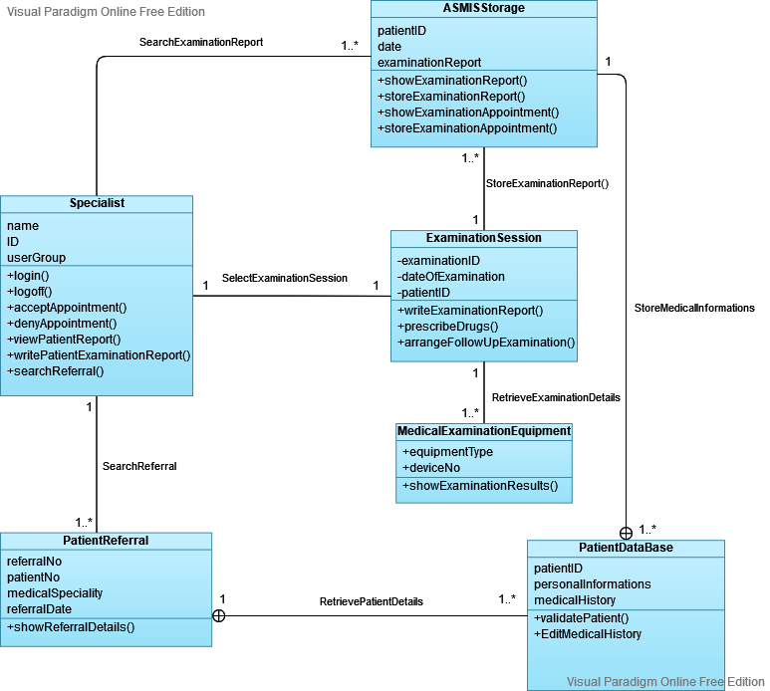

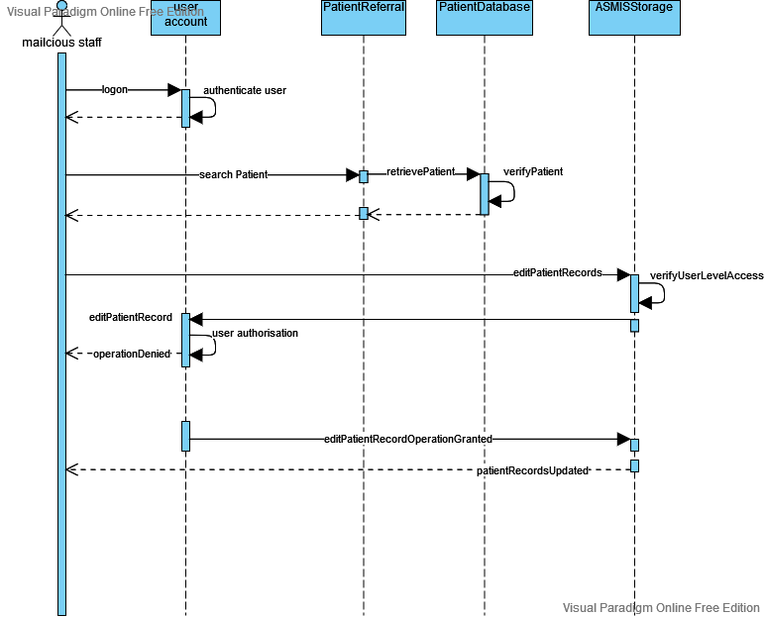

Additional UML diagrams which I probably like to use in the essay.

Would you recommend to use UML diagrams in the essay, which do not show aspects of the system, as well as threat modeling techniques?

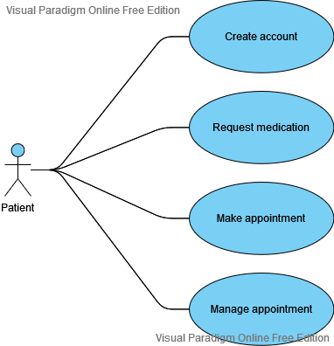

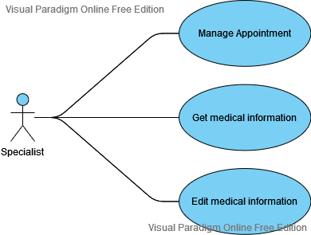

Based on the seminar session I am not sure anymore if the following UML diagram is right designed. Should I separate this UML diagram into two?

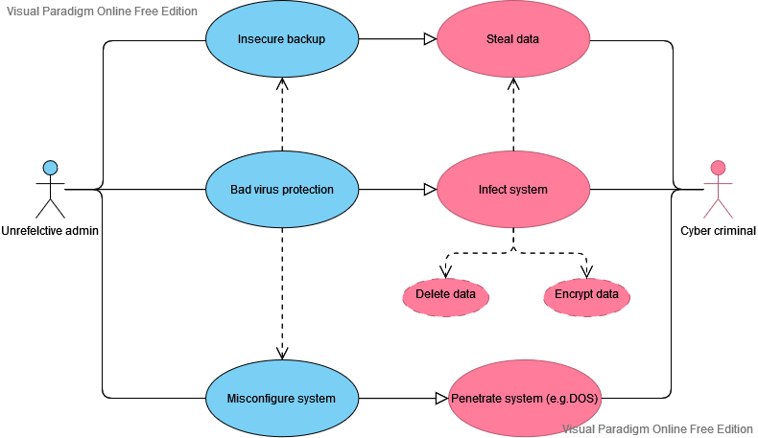

As a summary of the potential threats I thought, I show the following UML diagram. Here the same question as above: The UML diagram does not show explicit aspects of the system. Would you recommend to use it anyway, should I redesign it, or should I think about other possibilities to present the concerns I tried to visualize in this diagram?

